- Create a ConfigMap from a directory containing multiple files and inject the variables into a pod as environment variables.

Step 1: Prepare a directory with configuration files
Suppose you have a directory named app-configs/ with multiple files:
app-configs/
├── APP_ENV
├── APP_DEBUG
├── DB_HOST
Each file contains a single value:
# app-configs/APP_ENV
production

# app-configs/APP_DEBUG
false

# app-configs/DB_HOST
mongodb-service

Step 2: Create a ConfigMap from that directory
You can create a ConfigMap directly from a directory — each file becomes one key in the ConfigMap.
kubectl create configmap app-config --from-file=app-configs/
This will create a ConfigMap named app-config with keys:
APP_ENV
APP_DEBUG
DB_HOST

Step 3: Verify the ConfigMap
kubectl describe configmap app-config
Output (example):
Name: app-config
Data
====
APP_ENV:
----
production
APP_DEBUG:
----
false
DB_HOST:
----
mongodb-service

Step 4: Inject ConfigMap data as environment variables into a Pod
Create a Pod YAML (pod.yaml):
apiVersion: v1
kind: Pod
metadata:
name: configmap-env-demo
spec:
containers:
- name: demo-container
image: nginx
envFrom:
- configMapRef:
name: app-config
Here, envFrom automatically loads all key-value pairs from the ConfigMap into the container environment.

Step 5: Apply the Pod
kubectl apply -f pod.yaml

Step 6: Verify inside the container
You can check if the environment variables are loaded:
kubectl exec -it configmap-env-demo -- env | grep APP_
Output:
APP_ENV=production
APP_DEBUG=false
DB_HOST=mongodb-service

Summary:
- kubectl create configmap app-config --from-file=app-configs/
- Use envFrom in Pod to inject all as environment variables.

Would you like me to show how to inject only specific keys (instead of all) as environment variables too?

You said:
ubuntu@master:~$ kubectl apply -f pod.yaml pod/configmap-env-demo created ubuntu@master:~$ kubectl exec -it configmap-env-demo -- env | grep APP_ APP_DEBUG=false APP_ENV=production

ChatGPT said:
Perfect — that means your ConfigMap was successfully mounted and injected into the Pod as environment variables.
You can see that:
APP_ENV=production
APP_DEBUG=false
were loaded from your ConfigMap exactly as expected.
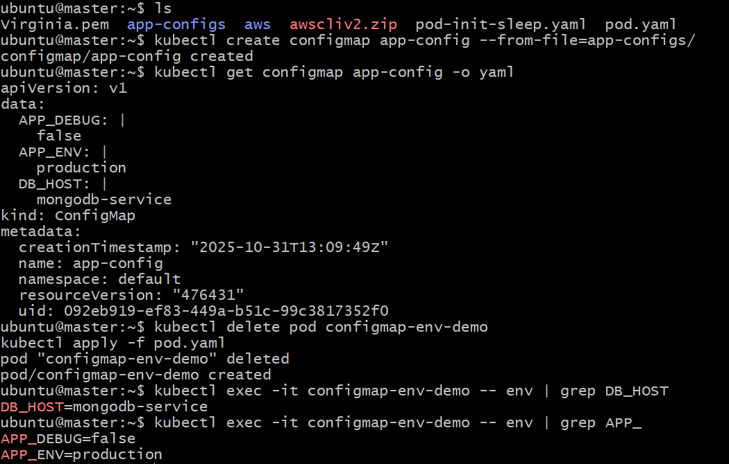
- Create a ConfigMap from a file and mount it as a volume inside a pod, ensuring the configuration data is available as files.

🧩 Step 1: Create a configuration file
Let’s create a file named app.conf:
cat <<EOF > app.conf
APP_ENV=production
APP_DEBUG=false
DB_HOST=mongodb-service
EOF

🏗️ Step 2: Create a ConfigMap from that file
kubectl create configmap app-config-file --from-file=app.conf
✅ This creates a ConfigMap named app-config-file with one key (app.conf) whose value is the file’s contents.

🔍 Step 3: Verify the ConfigMap
kubectl get configmap app-config-file -o yaml
You should see:
data:
app.conf: |
APP_ENV=production
APP_DEBUG=false
DB_HOST=mongodb-service

🚀 Step 4: Create a Pod and mount the ConfigMap as a volume
Create a file pod-volume.yaml:
apiVersion: v1
kind: Pod
metadata:
name: configmap-volume-demo
spec:
containers:
- name: demo-container
image: nginx
volumeMounts:
- name: config-volume
mountPath: /etc/config
volumes:
- name: config-volume
configMap:
name: app-config-file
✅ This means:
- The ConfigMap’s data will appear inside the container under /etc/config/
- Each key from the ConfigMap becomes a file inside that directory
→ In this case, /etc/config/app.conf

⚙️ Step 5: Apply the Pod
kubectl apply -f pod-volume.yaml

🧠 Step 6: Verify inside the Pod
Check the mounted file:
kubectl exec -it configmap-volume-demo -- ls /etc/config
Expected output:
app.conf
View the file contents:
kubectl exec -it configmap-volume-demo -- cat /etc/config/app.conf
Expected output:
APP_ENV=production
APP_DEBUG=false
DB_HOST=mongodb-service

✅ Result:
Your ConfigMap has been mounted as a volume, and its data is now available as files inside the container.
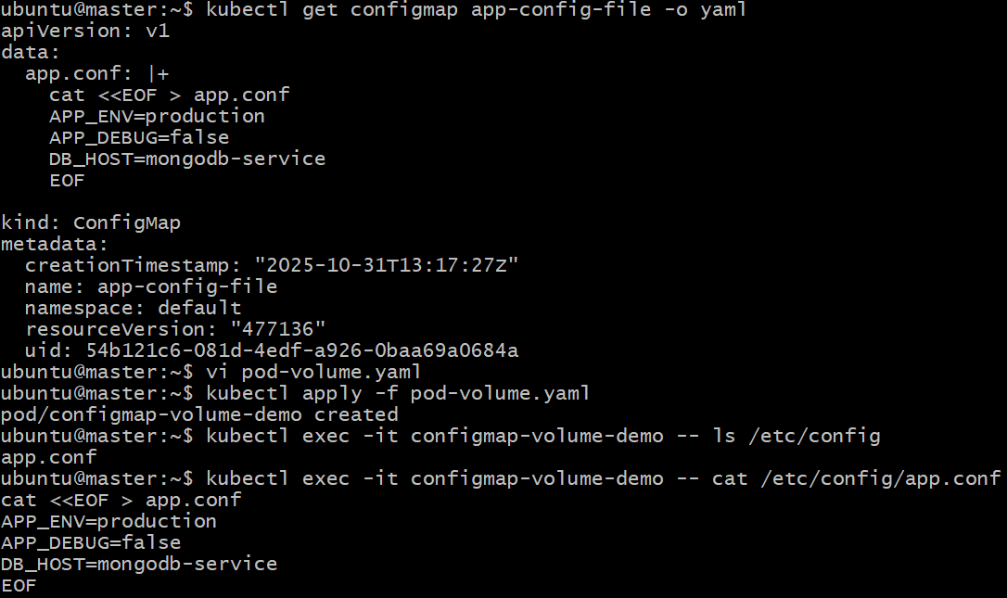

- Create a Secret with sensitive information (username and password) and inject it into a pod as environment variables.

🧩 Step 1: Create a Secret from literals
Use kubectl create secret with the generic type and --from-literal flags:
kubectl create secret generic db-credentials \
--from-literal=username=admin \
--from-literal=password=SuperSecret123
✅ This creates a Secret named db-credentials with two key-value pairs:
username=admin
password=SuperSecret123

🔍 Step 2: Verify the Secret
kubectl get secret db-credentials -o yaml
Output (values are base64 encoded):
data:
password: U3VwZXJTZWNyZXQxMjM=
username: YWRtaW4=
type: Opaque
If you want to decode and verify locally:
echo "U3VwZXJTZWNyZXQxMjM=" | base64 --decode

🚀 Step 3: Create a Pod and inject the Secret as environment variables
Create a file secret-env-pod.yaml:
apiVersion: v1
kind: Pod
metadata:
name: secret-env-demo
spec:
containers:
- name: demo-container
image: nginx
env:
- name: DB_USERNAME
valueFrom:
secretKeyRef:
name: db-credentials
key: username
- name: DB_PASSWORD
valueFrom:
secretKeyRef:
name: db-credentials
key: password
✅ Here:
- The Pod reads values from the db-credentials Secret.
- Inside the container, you’ll have:
- DB_USERNAME=admin
- DB_PASSWORD=SuperSecret123

⚙️ Step 4: Apply the Pod
kubectl apply -f secret-env-pod.yaml

🧠 Step 5: Verify inside the container
Run:
kubectl exec -it secret-env-demo -- env | grep DB_
Expected output:
DB_USERNAME=admin
DB_PASSWORD=SuperSecret123

✅ Result:
You’ve successfully:
- Created a Secret (db-credentials)
- Injected it into a Pod as environment variables
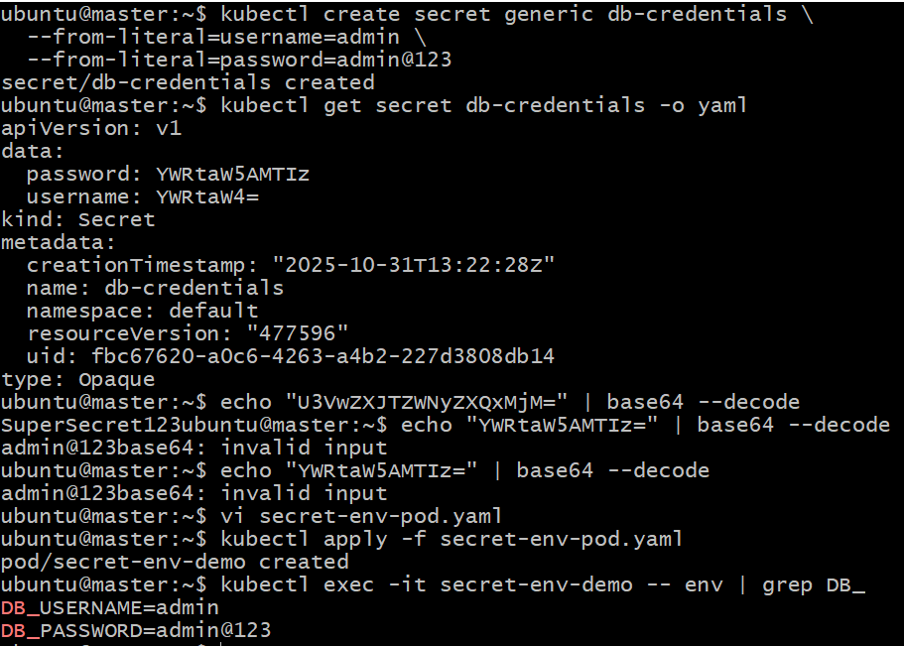
- Create a Secret using a YAML file, mount it as a volume in a pod, and verify the specific Secret values are available as files.

🧩 Step 1: Create the Secret manifest (secret.yaml)
Create a YAML file named secret.yaml:
apiVersion: v1
kind: Secret
metadata:
name: db-secret
type: Opaque
data:
username: YWRtaW4= # base64 for "admin"
password: U3VwZXJTZWNyZXQxMjM= # base64 for "SuperSecret123"
⚠️ Note: Secret values must be base64 encoded.
To encode your own values:
echo -n "admin" | base64
echo -n "SuperSecret123" | base64

🏗️ Step 2: Apply the Secret
kubectl apply -f secret.yaml
Verify:
kubectl get secret db-secret -o yaml
You should see:
data:
password: U3VwZXJTZWNyZXQxMjM=
username: YWRtaW4=
type: Opaque

🚀 Step 3: Create a Pod and mount the Secret as a volume
Create a file named pod-secret-volume.yaml:
apiVersion: v1
kind: Pod
metadata:
name: secret-volume-demo
spec:
containers:
- name: demo-container
image: nginx
volumeMounts:
- name: secret-volume
mountPath: /etc/secret-data
readOnly: true
volumes:
- name: secret-volume
secret:
secretName: db-secret
✅ Explanation:
- secretName: db-secret → mounts that Secret.
- Files are created in /etc/secret-data/:
  - /etc/secret-data/username
  - /etc/secret-data/password

⚙️ Step 4: Apply the Pod
kubectl apply -f pod-secret-volume.yaml
Wait for it to run:
kubectl get pods

🧠 Step 5: Verify inside the container
List the mounted files:
kubectl exec -it secret-volume-demo -- ls /etc/secret-data
Expected output:
password
username
View their contents:
kubectl exec -it secret-volume-demo -- cat /etc/secret-data/username
kubectl exec -it secret-volume-demo -- cat /etc/secret-data/password
Output:
admin
SuperSecret123

✅ Result:
You’ve successfully:
- Created a Secret using YAML
- Mounted it as a volume in a Pod
- Verified that the Secret values are available as files inside the container
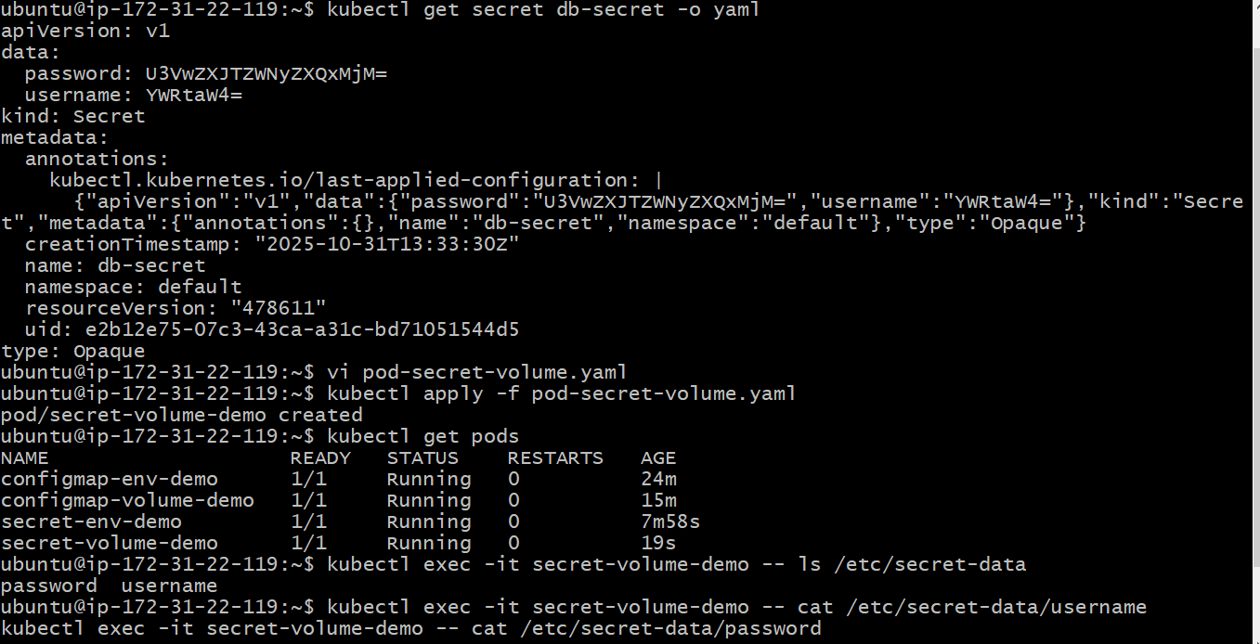
- Inject a ConfigMap as environment variables and a Secret as files into the same pod, ensuring both are accessible within the pod.

tep 1: Create a ConfigMap
Let’s create one with some environment variables:
kubectl create configmap app-config \
--from-literal=APP_ENV=production \
--from-literal=DB_HOST=mongodb-service
Verify:
kubectl get configmap app-config -o yaml

🔐 Step 2: Create a Secret
We’ll store database credentials as sensitive info.
kubectl create secret generic db-secret \
--from-literal=username=admin \
--from-literal=password=SuperSecret123
Verify:
kubectl get secret db-secret -o yaml

🏗️ Step 3: Create a Pod that uses both
Create a file named pod-configmap-secret.yaml:
apiVersion: v1
kind: Pod
metadata:
name: combined-demo
spec:
containers:
- name: demo-container
image: nginx
envFrom:
- configMapRef:
name: app-config # inject ConfigMap as environment variables
volumeMounts:
- name: secret-volume
mountPath: /etc/secret-data
readOnly: true # mount Secret as files
volumes:
- name: secret-volume
secret:
secretName: db-secret
✅ Explanation:
- envFrom.configMapRef: loads all key-value pairs from app-config as environment variables.
- volumes.secret.secretName: mounts the Secret as files in /etc/secret-data/.

⚙️ Step 4: Apply the Pod
kubectl apply -f pod-configmap-secret.yaml

🧠 Step 5: Verify inside the Pod

🔹 Check ConfigMap environment variables
kubectl exec -it combined-demo -- env | grep APP_ENV
kubectl exec -it combined-demo -- env | grep DB_HOST
Expected output:
APP_ENV=production
DB_HOST=mongodb-service

🔹 Check Secret files
kubectl exec -it combined-demo -- ls /etc/secret-data
Expected output:
password
username
Then:
kubectl exec -it combined-demo -- cat /etc/secret-data/username
kubectl exec -it combined-demo -- cat /etc/secret-data/password
Output:
admin
SuperSecret123

✅ Final Result Summary
Type | Source | Mounted/Ingested As | Location
ConfigMap | app-config | Environment vars | env inside container
Secret | db-secret | Files (read-only) | /etc/secret-data/
